What is the Impact of Context Switching on the Ability to Deliver?
Many people think that they can multi-task, or rather that they can be just as effective switching between multiple tasks on a regular basis rather than concentrate on one task at a time. While I am certain that there are people that can do this effectively, for knowledge work in particular most people are not good at context switching. The effect of context switching is pretty high. Consider the diagram:
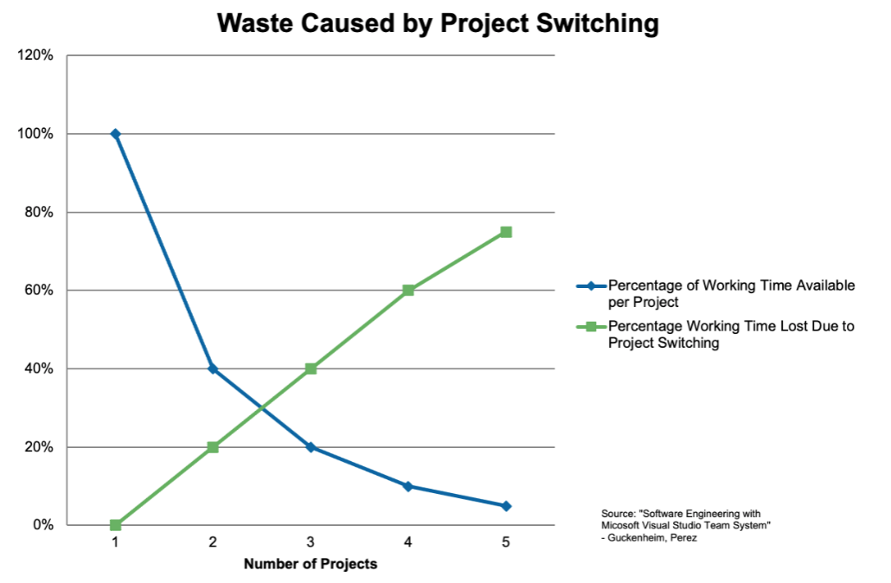
The summary of this slide is:
Switching context between two tasks reduces your effective capacity by 20%; between three tasks doubles that.
Perhaps you don't think you are effected in this way? Here is a simple exercise to find out. Our task is to time ourselves as we produce a page with the numbers from 1 to 10, the letters from A to J, and the roman numerals from I to X:

The first time we time ourselves we will write the numbers down in column order, so 1 through 10, then A through J, and finally I through X. We will then turn over the page and try it again, but this time we will write down each row. So we will produce 1, A, I then 2, B, II until we complete the 10th row.
If the time recorded for the first round versus the second round are basically the same then congratulations you are one of a small group of people (2%) that seem to be effective when multi-tasking. If you are like the rest of us, you find a significant difference and that difference will look similar to the data in the diagram above. To calculate:
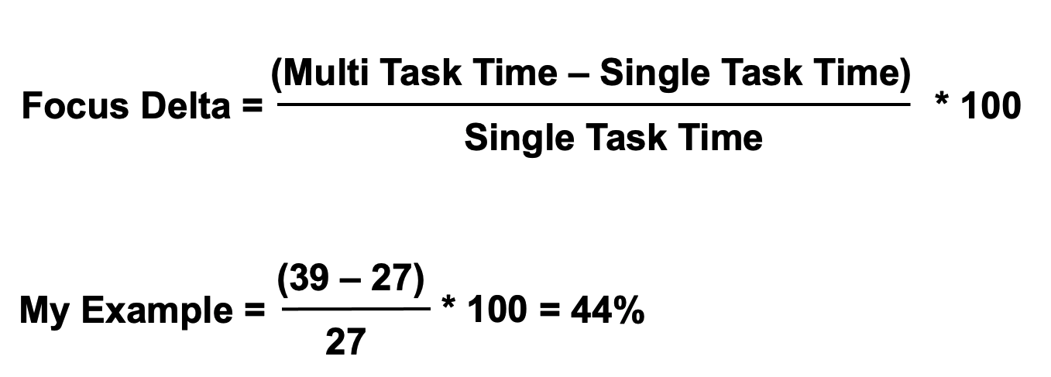
Interesting, isn't it?
In addition to the time, the other thing to note is the error rate. My experience is that when I do this the second time around and I go back and validate what I've produced, that there are more mistakes in the second round of processing.
This is an analysis based on an individual's capacity, but in my experience the same effect applies to Teams and Organizations. This is not really a surprise in that, for example, if your whole team needs to switch context then it will take a significant amount of the Team's capacity to make the adjustment.
This is not to say you shouldn't context switch. Clearly there is sometimes a need to do it. What I've found is that I can reduce the impact of context switching by becoming more deliberate about the work I take on or perhaps, more importantly, when I take on work. If I operate in “react mode” to incoming work, I will see the full effect of the reduction in capacity from a context switch. On the other hand, if I respond to incoming work by making it something I plan to do, the impact of the context switch is far less. There is still a reduction in capacity as we switch between work, but we are in control of when we take that hit.
Bottom line is that the more context switching you (as an individual, Team, or organization) have, the less capacity you will have available to do work which means you produce less, and the higher the error rate is for all work you do.

Want To Know More?
- Why Should We Focus on Doing One Thing To Completion at a Time? for additional reasons that we should not multi-task.

