What insights do we get from tracking Investment Horizon?
How do ensure that we are not just providing solutions for today, but are also positioning ourselves for the future with new expansion opportunities? We guide investments by horizon data on Initiatives. Typically a balance is required so we are continuously developing solutions for now but also have a pipeline for the future expansion. Portfolio Management set targets for how much of our capacity is applied to each level, and then reviews these targets based on actuals.
Geoffrey Moore in the book “Escape Velocity: Free Your Company’s Future from the Pull of the Past” describes a model for guiding investments by horizon data on Initiatives. Portfolio Management set targets for how much of our capacity is applied to each level, and then reviews these targets based on actuals.
A typical model looks like:
- Horizon 3 (evaluating): Creating viable options potentially including new category products, exploration into new markets and exploration of new technologies.
- Horizon 2 (emerging): Building emerging offerings; an internal businesses on the rise. We have customers. We have possibly found product-market fit. We are ready to scale. Focus is on existing market we do not serve (potentially) using existing technology that we do not currently use. We are building our next generation products. Adjacent growth.
- Horizon 1 (investing and extracting): Extend and defend the core of the business; generate cash needed to operate the business. We have a well understood business model. We focus on improvements, extensions, variations, cost reduction aimed at the existing market, and using existing technology.
- Horizon 0 (retiring): Deprecation and simplification of solution offering and technologies aimed at reducing operating costs and duplication. This frees up staff to focus on other opportunities.
Or pictorially:
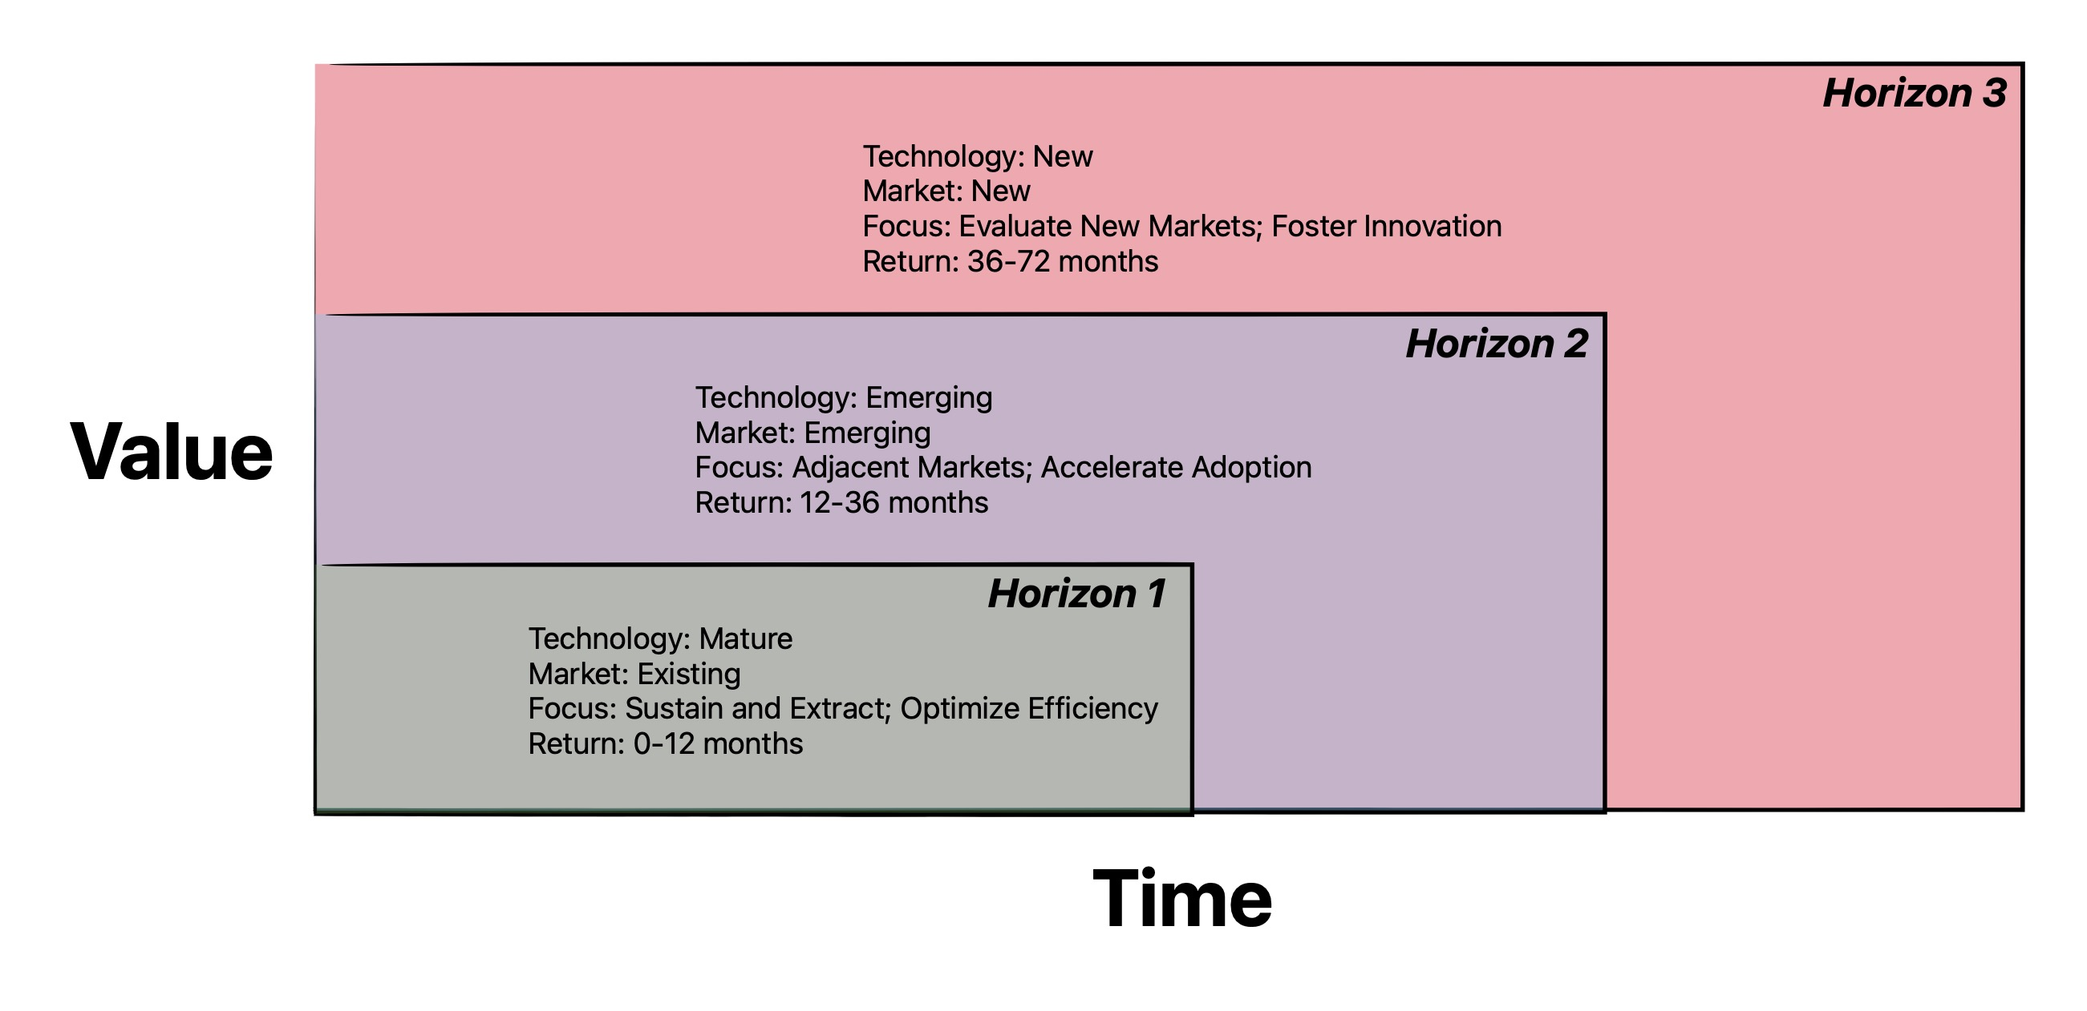
Source: Composite
To help with this type of thinking, it is useful to think of these investments through a financial lens. Venture Capital (VC), Private Equity (PE), and Private Banking (PB) companies are distinct entities in the financial sector, each with its own focus and thinking process. Here's a breakdown of their differences:
- Venture Capital (VC):
  - Focus: Venture capital firms provide funding to early-stage, high-potential startups and small businesses with significant growth potential.
  - Thinking Process: VCs typically invest in companies that operate in emerging industries or disruptive technologies. They aim to generate substantial returns on their investments by actively participating in the company's growth, offering expertise, mentorship, and industry connections.
  - Investment Approach: VCs know that not a lot of their investments will pay off, and so invest in many (10’s) of companies with the expectation that 1 will have truly significant payoff.
  - Equivalent Horizon Interest: Horizon 3
- Private Equity (PE):
  - Focus: Private equity firms invest in more mature companies with established operations and growth potential. They often acquire a controlling stake in the company.
  - Thinking Process: PE firms employ various strategies like leveraged buyouts or growth capital injections to enhance the company's value. They work closely with management teams to improve operational efficiency, streamline processes, and ultimately maximize the value of their investment.
  - Investment Approach: PEs have the knowledge that the business case is known, so the issue is whether they can grow and so offer returns substantial incremental returns across the portfolio.
  - Equivalent Horizon Interest: Horizon 2
- Private Banking (PB) Companies:
  - Focus: Private banking companies offer personalized financial services to high-net-worth individuals, families, and institutions. Their services encompass investment management, wealth planning, estate management, and more.
  - Thinking Process: Private banks prioritize building long-term relationships with their clients, understanding their financial goals, risk tolerance, and specific needs. They provide tailored investment solutions, asset allocation advice, and comprehensive wealth management strategies to preserve and grow their clients' wealth.
  - Investment Approach: PBs operate in support of the existing offering.
  - Equivalent Horizon Interest: Horizon 1
Horizon 1 investments are expected to contribute material returns in the same fiscal year in which they are brought to market, thereby generating today’s cash flow. Horizon 2 investments are expected to pay back significantly, but not in the year of their market launch. Horizon 3 investments are investments in future businesses that will pay off in the out years beyond the current planning horizon. Horizon 0, not represented above, are the investments required decommission a solution or technology.
The implication is that success metrics for any one horizon are inappropriate for the other two. The metrics for Horizon 3 correlate instead with achieving “early market success” or “product market fit”. The goal for Horizon 2 is to “cross the chasm” between a few flagship customers and being a going concern. The goal for Horizon 1 is to run a profitable and sustainable business and tends to be focused on making the operation more efficient (product better, faster, and cheaper) as well as extensions to the current market.
In addition, the kind of work to be done will be different based on what horizon we are operating in. For example, as we search for product market fit for Horizon 3 work we can expect the work to centred on experimentation, ensuring that we are generating fast and cheap feedback loops to determine the overall direction we should go. The work is more about “learning” than it is abut delivering customer value. This process could last a long time, hence the need for “cheap” experiments to generate the right kind of feedback. Contrast this with Horizon 1 work, where we have product market fit good systems in place to deliver value, and so the work is more about incremental delivery of value. But the potential returns are also significantly different - Horizon 3 work offers the potential for significant growth into new markets, whereas Horizon 1 work will result in incremental, although large, returns for example perhaps even focussed on retaining existing customers rather than generating new revenue.
Horizon 1 work effectively pays for Horizon 3 and, up to a point Horizon 2 work. Horizon 1 is the “cash cow” for the organization. This thinking brings up another issue for many organizations. Because Horizon 1 work typically represents the the large potion of income coming into an organization and is relatively a known quantity, it is easy to prioritize this work over the high risk, relatively lower income (in the short term) of Horizon 3 work. The metaphor I’ve heard is that it is like comparing “whales and minnows”. Having said that, leadership understands that if we do not invest in this Horizon 3 work, then they risk the company dying as a result of lack of growth or inability to respond competitively. For this reason, it is often best to have specific capacity allocations targeted to Horizon 1 vs 2 vs 3 work and the to prioritize efforts within those capacity allocations. That way we can compare “whales to whales” and “minnows to minnows”. Typical allocations of capacity I’ve seen are 70% allocated to Horizon 3, 20% to Horizon 2, and 10% to Horizon 1.
Further, we can apply different prioritization strategies to these Horizons. For example, we might need a prioritization strategy that selects say 10 experiments we want to run for Horizon 3 as we are uncertain of which experiment in going to “win”. The idea of an ROI applied to these experiments makes no sense - the ROI will eventually be as a result of the basket of experiments, and then not guaranteed. In contrast, for Horizon 1 we might look at “expected impact of new feature” for prioritization.
We will need to both establish targets for the Investment Horizon, both at the Portfolio and Program level (sometime at the Team level as well), and then report on how we are doing with respect to these targets. From a tooling perspective, this is done by tagging Initiatives, Features and (optionally) stories with Investment Horizon. Typically a dashboard report would show percentage investment in each Investment Horizon at the Portfolio, Program, and Team levels, trended over time, to ensure we have visibility into this level of decision making.

