"Scrum at Scale" by Jeff Sutherland
Jeff Sutherland on Scrum at Scale at GOTO Conference in Amsterdam in 2015.
While this has the same title as other Webinars, this one was pretty useful in that it described a lot more what management needed to do and how to organize.

Presenters
Jeff Sutherland

Learning / Actions
- Idea – two operating systems in org – new one for innovation, not same system
- Idea – test driven development to improve traceability.
- Idea – move organization from pathological or bureaucratic organization to Generative organization with focus on mission, everything subordinated to good performance, look for basic problems in the system
- Idea – “leadership refractors organization”
- Idea – meta-scrum – Output is aligned product backlog. Gathering of key stakeholders, leadership, and product owners
- Document role of management
Thing I think this misses a little is the idea that management is “responsible for the system.” It is implied by expected actions but does not seem to state it explicitly.

Materials
Video Scrum at Scale
References
- Book – HBR Press 2014. John Kotter “Accelerate” (XLR8)
- https://hbr.org/2015/01/building-a-software-start-up-inside-ge
- https://hbr.org/2014/04/how-ge-applies-lean-startup-practices
- Book “Lean Enterprise” Jez Humble

Notes
So many people to get so little done
Only 20% of people getting to completion / delivery of software at the end of a sprint.
If 100% predictability then have zero innovation
Two axis chart Process – follow the rule vs continuous improvement Design – innovation vs convergent design
And you are moving
Affects how you scale an organization
Defense contractor How use points to report to government
Autodesk How to raise impediments
Spotify How to achieve a vision in multiple team oriented culture How release to the customers
Agile is “lean” plus “customer collaboration“ Management needs to be retrained to eliminate waste
Need to get management agile Leadership development
See chart “modular framework using Scrum” Product owner flow Scrum master flow
Goes into and goes out of, and process
Scrum How get on Moores Law but applied to software
Beginning Done Continuous deployment
Agile leadership can scale twice the work in half the time
At OpenView Venture Partners Looked at results for all their organizations Plotted story points produced vs work week Found max story points was less than 40 hour weeks. Peak of productivity Waterfall tended to have longer workweeks, and produced less Called resultant chart “The Maxwell Curve” after Scott Maxwell, Founder OpenView
Note while agree with message, think chart is a bit strange as it implies that teams that work 60 hours per week produce 0 value, which is wrong. I expect they will produce some value, but not as much, and may have some negative effect (as a result of introducing new bugs) but don’t expect it to get to zero with 20 extra hours, based on my own experience.
Book – HBR Press 2014. John Kotter “Accelerate” (XLR8)
Message need both leadership and management Two axis- low to high Management and leadership applied to execs, managers, and employees
Low leadership and low management – doomed (eg bellsouth, Nokia) Low leadership and high management – well run but bureaucratic and unable to change quickly (eg most large successful companies) High leadership and low management – innovative, energetic and adaptive but chaotic (eg most startups) High leadership and high management – well run and innovative, energetic and adaptive (eg Spotify, Apple, Google) Kotter Build two operating systems One for existing and one for the new stuff
If don’t then you have agile implementation that sucks
Read two articles
https://hbr.org/2015/01/building-a-software-start-up-inside-ge https://hbr.org/2014/04/how-ge-applies-lean-startup-practices Message from traditional development We want development to Go faster but we still want all the old reports.
Book “Lean Enterprise” Jez Humble about innovation at scale
Defines 3 types of org. Based on who can provide good safe services.
- Pathological – people hoard information to make themselves look better, generates a large amount of fear and threat, look for scapegoats
- Bureaucratic – protect department, maintain turf, insist on rules, seek justice
- Generative – focus on mission, everything subordinated to good performance, look for basic problems in the system
Need to become generative
Generative organizations can deal with organizational debt Eg because of dependencies cannot get anything out the door in less than 7 months (Eg Skype)
“Spaghetti organizations”
Many companies are driven by compliance Can still do But need two operating systems
Idea – test driven development to improve traceability.
CEO changes management roles:
- Management coaches teams to self organize and self manage. Managers become leaders
- teams self organize against prioritized backlog – are teams organized to maximize production
- leaders create virtual teams that drive CoP across companies
- leadership refactored organization
Managers become leaders. Role includes:
- Provide challenging goals for the teams
- Create a business plan that works
- Eliminate organizational debt
- Orovide all resources a team needs
- Identify and remove impediments for the teams
- Know velocity of the teams
- Remove waste – eliminate technical debt
- Hold product owners accountable for value delivered per point
- hold scrum master accountable for process improvement and team happiness
Evolution of organizations
- Organizations are becoming smaller 50-150 people
- And then federated to become multi-billion dollar orgs
- Each org has own management and financial structure
- Corporate headquarters becomes small group rolling up financials and working with stakeholders and investors
- Leadership in federated organizations is lean and executes agile practices
Strategy for scaling
- Scale down, not up
- Scale out
- Scale in not out – align around the vision
Key to do agile well
Form agile action team
52% of agile teams cannot deliver on time etc This is agile in name only
See picture 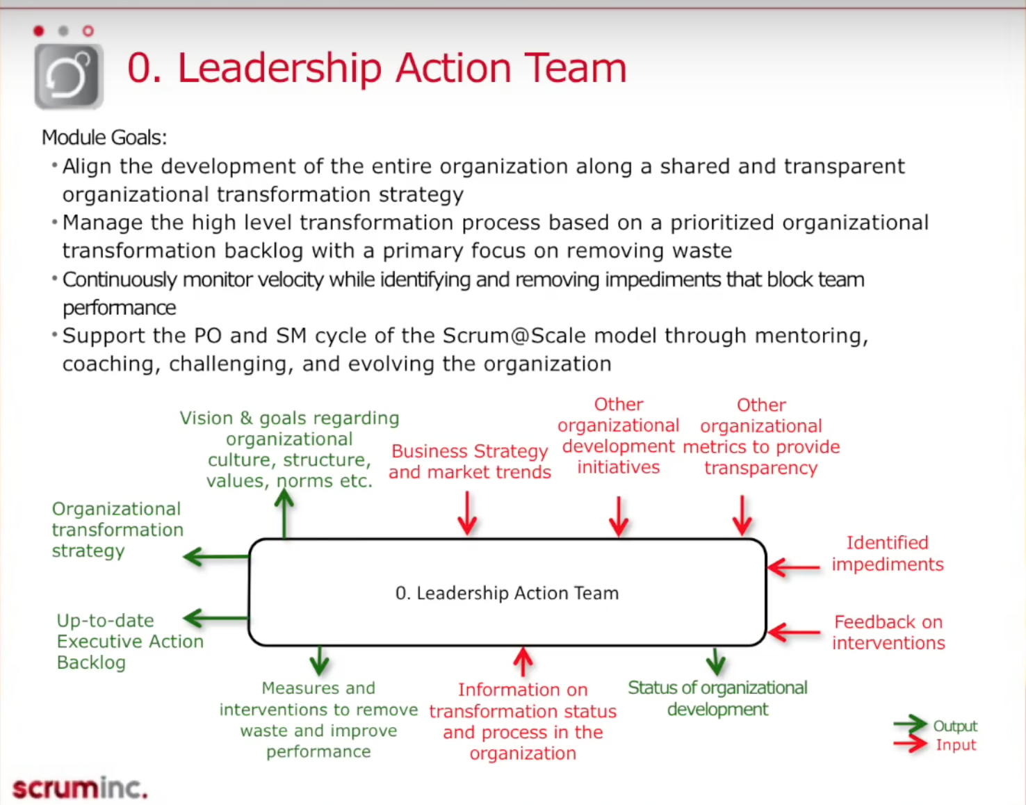
Best illustration is from team of teams – mccrystal
Stay on top of this else org will self destruct
Deal with impediments Mid management usually stops this
At John Deere if a SM hasn’t raised an organizational impediment in three sprints then she is replaced. Interesting idea to surface impediments.
Idea – meta-scrum – Output is aligned product backlog Gathering of key stakeholders, leadership, and product owners Run by Chief Product Owner Forum for stakeholders to express preferences and remove blocks They should not alter product visions between meta-scrums Allows teams to progress efficiently down single workpath Help on cadence or ad hoc Output is aligned product backlog
What specifics can action team focus on
- Too many projects in pipeline (context switching)
- everything is top priority
- pressure to get things done delays projects and reduces quality
- lack of understanding of scrum, agile, lean etc
- fear of exposure or change in responsibilities
- no continuous integration or automated testing
- coaches / scrum masters not surfacing impediments
- management not focused on removing waste
Some things that need to change
- reporting – get rid of time card reporting. Report on production, not hours
- recruiting – Hire for teams
- job descriptions – focus on team contribution
- incentive plans – reward team performance
- performance appraisals – get rid of yearly
- space for teams – collocation works best
Deploy aggressive scrum The faster you go the more resistance there is Like team of bike riders scrum master may need to peel off to go faster

