How Do We Use Agile to Reduce Costs?
Or “Why Is It That Our Agile Implementation Doesn’t Lead to Cost Savings?”
In many IT organizations that I have worked with, there is a focus on controlling and reducing costs. This makes sense as most IT organizations are regarded as cost centers, and so it is thought, a focus on reducing costs should result in improved business outcomes for all concerned.
This thinking leads to a focus on efficiency, utilization rates and so on with the theory that if we can get more out of a resource (for example, a person), then we will be better off.
For those with this focus, what actually happens as they implement agile is a disappointment. Usually there is no visible reduction in cost and no visible improvement in efficiency. Worse, it looks like as we implement agile that things like utilization rates will decrease as we staff roles such as Product Owners, Scrum Masters, and so on.
Agile is focused on delivering the most value given the known capacity.
Some of this comes from a base misunderstanding of what agile is about. Agile is not about using our resources more efficiently. It is not cost focussed. Agile is focused on delivering the most value, as defined by our customers, given the known capacity. Agile delivers more value because:
- It helps teams know what the most valuable thing they could work on right note
- It focuses on flow efficiency, not resource efficiency, which reduces handoffs, reduces context switching, and wasted additional work. This is a result of aligning our work execution directly with customer needs
- It introduces slack into the system which helps because high utilization rates actually result in lower throughput and higher lead and cycle times.
How much additional value is delivered? Your mileage will vary. A recent implementation I worked (agile transformation of around 1000 people) showed improvements of hard benefits delivery of over 100% year on year.
“But”, I hear you say, “if we are delivering more than we ever have, surely this means that we can reduce costs.” That is true; you could do that.
In reality there is always more demand on our capacity than our ability to fulfill the demand. This means that rather than reducing capacity, most organizations just take on more demand.
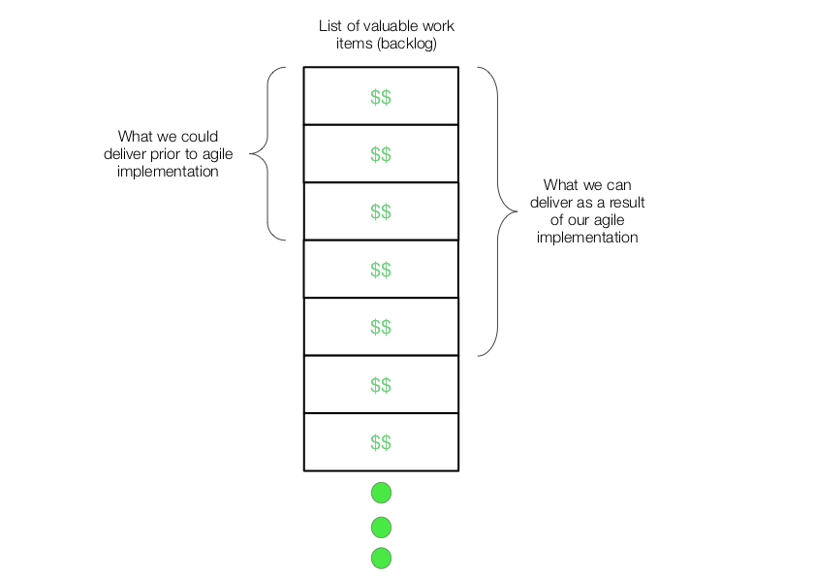
So while it is possible that organizations could reduce the number of people they have, they don’t. Ironically, this means the organization’s cost structure will remain the same.
An outsider with the traditional cost oriented mindset doesn’t see the additional value delivered, just the cost. If you were to point out to people that there is more value delivered most people would be happy with that. But this is not usually the discussion. What is happening here? The problem is that “value delivered” is hard to measure. Most organizations don’t do a great job of measuring it. Worst, value takes a long time to manifest (it’s a lagging metric) and it is not always clear that this particular investment resulted in a specific return. Contrast this with measuring cost, which usually easy to measure and where actions taken today almost have immediately visible results.
Now don’t get me wrong. Understanding cost is important. But if we focus only on cost using our traditional mindset (efficiency, utilization, etc.), we end up actually being less effective in delivering value.

