Agile 2016 Conference in Atlanta, GA

Premise
Notes from the Conference.
2500 people 42 countries 1/3 SM, 1/3 Exec, 1/3 product owner
18 tracks 19 session at same time 220 sessions

Additional Activities

My Proposal
I sent the following proposal into the submission session. Past experience indicates that if you submit one session the probability of getting it accepted is pretty low but this one was accepted.
- How to Work Personality Issues Without Sounding Like a Marriage Guidance Counsellor?

Volunteering
This year decided to volunteer and was happy to be accepted. Bottom line is that, as I got accepted as a speaker, I was put in as an “honorary volunteer”. Had a lot of fun meeting a bunch of folks from all around the world.
Also I enjoyed attending sessions that I probably wouldn't have been inclined to see and, must say, it was pretty amazing at what you could learn. The session on (for example) strong-style pairing offered some serious learning both in terms of how to present something in a workshop (hint: everyone has a smartphone - figure out a way to use it) and in terms of how to learn.
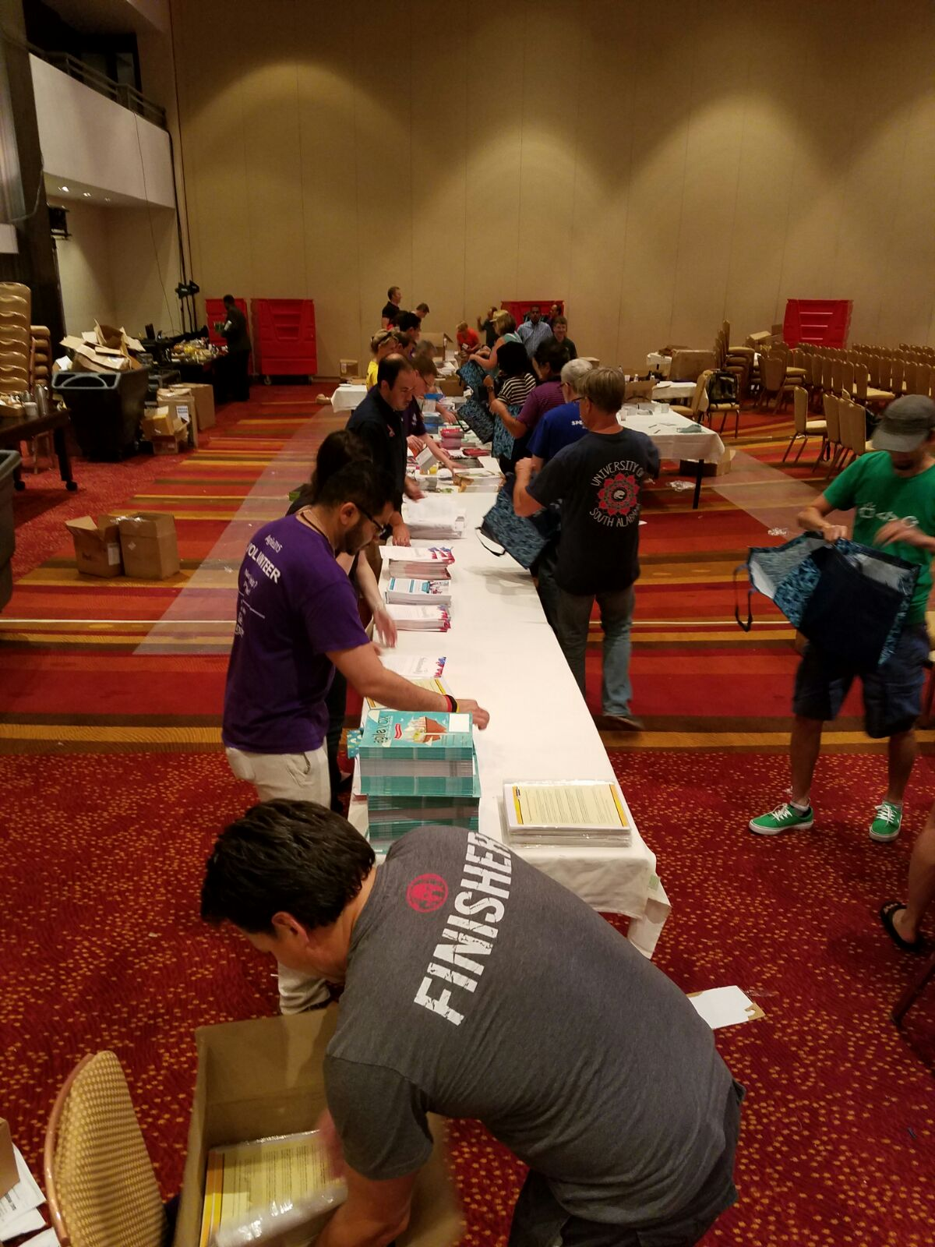

Sessions Notes

Monday
- Jurgen Appelo - Managing For Happiness
- Mike Cottmeyer - The Executives Step-by-Step Guide to Leading Large-Scale Agile Transformation
- Llewellyn Falco and Maaret Pyhajarvi - Strong-Style Pairing

