2017 Completed Events
Event | Type | Location | Date | Comments
Leadership Workshop | Coaching | Houston | 2017-11-28 | Workshop aimed at helping top level supervisors understand what they need to know and do to drive the transformation
Value Stream Mapping | Coaching | Houston | 2017-10-25 | Value Stream mapping for Foundation Infrastructure group
Initial PI Planning | Coaching | Houston | 2017-10-23 | Crazy (AtC). 5 Teams. 100 people at event. SAFe event.
Leading SAFe | Training | Houston | 2017-10-19 | Leadership of the XOM FI AtC Train plus guests. 32 people.
SAFe for Teams | Training | Houston | 2017-10-16 | AtC (Crazy) Train. 42 people.
Kanban Team Kickoff | Training | Budapest | 2017-10-09 | New teams on the way to Agile Release Train
Initial PI Planning | Coaching | Houston, Buenos Ares, Kuala Lumpur | 2017-10-02 | Bullet (Storage). 3 Teams. Initial XOM Foundation Infastructure (FI) Train. SAFe event.
SAFe for Teams | Training | Houston | 2017-09-25 | Half the Storage (Bullet) Train. 24 people. New SAFe 4.5 materials.
Kanban Team Kickoff | Training | Houston / Buenos Aires | 2017-09-12 | 2 new teams on the way to Agile Release Train
Leading SAFe | Training | Houston | 2017-08-21 | Leadership of the XOM FI Storage Train. 10 people. New SAFe 4.5 “Leading SAFe” materials.
Kanban Team Kickoff | Training | Houston | 2017-07-24 | 2 new teams on the way to Agile Release Train
SAFe 4.5 Update | Attend | Virtual | 2017-06-27 | Understand updates for SAFe 4.5 (see summary at 5 Reasons to Update and My Notes)
Enterprise Lean-Agile Coach Course with OrgMindset.com | Attend | Boulder | 2017-06-07 | 3 day course with Alex Yakyma. See My Notes. Passed test and certified as Enterprise Coach - 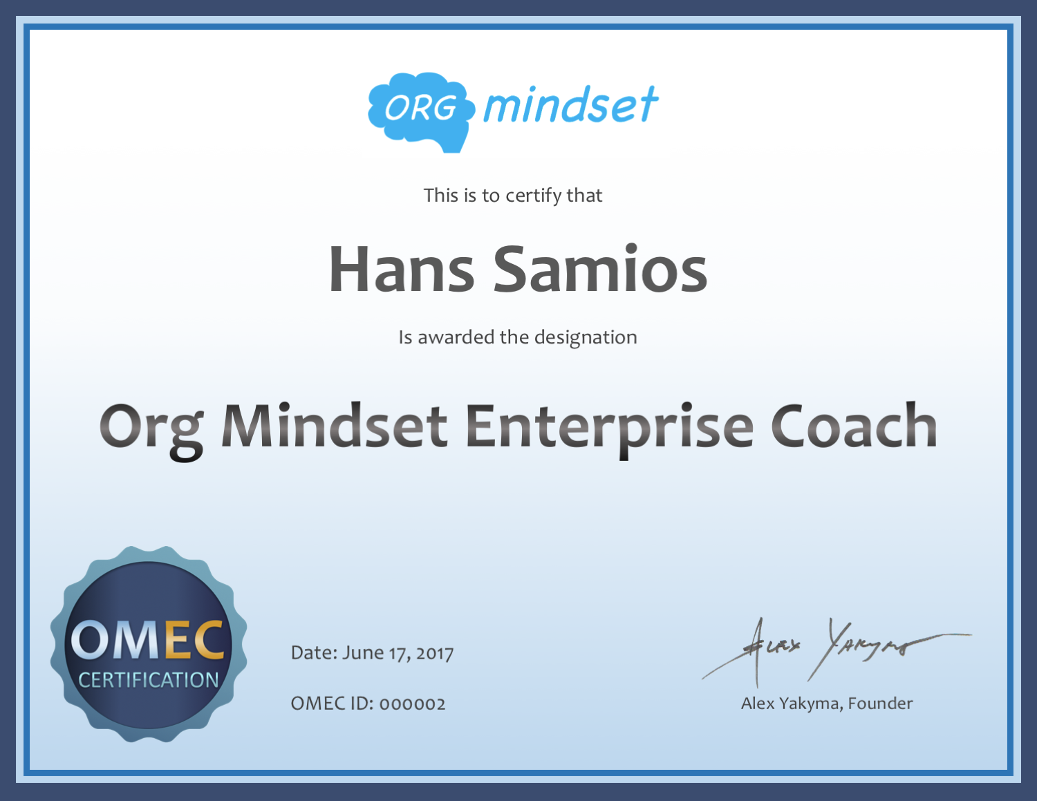
Value Stream Mapping and Lean Coffee | Training | Houston | 2017-05-08 | Train the trainer session. Facilitated
Leaders Introduction to Agile | Training | Houston | 2017-05-01 | Three sessions aimed at helping leadership understand how the pilots work, and understand what learning they will need.
Kanban Team Kickoff | Training | Kuala Lumpur | 2017-04-17 | 3 Teams. Co-taught
Kanban Team Kickoff | Training | Houston | 2017-04-10 | 2 Teams. Co-taught.
Ongoing until 2017-12-31 | Transformation Coach | Houston | 2017-03-15 | Co-coach with Transformation Team
Implementing SAFe | Training / Coaching | Scottsdale | 2017-01-31 | Co-taught
SAFe Advanced Scrum Master Enablement | Certification | Virtual | 2017-01-27 | 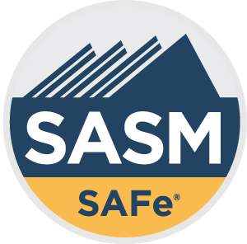SASM certification
Difficulties and Benefits of Working in Agile Environment | Training | Belmont University | 2017-01-23 | 16 Seniors

