Todd Little and Andrew Tuttle - Performance Reviews That Don’t Suck

Premise
Many in the agile community suggest abandoning performance reviews, but few offer suggestions for alternatives. A large percentage of software developers work in an enterprise environment where performance reviews are mandated. What if you could do performance reviews that will honor agile values and not only suck less, but actually provide value to the individual and the organization? We have rolled out such a system successfully with strong support across the enterprise–from the individual colleagues, to people leaders, and even including HR. We will demonstrate the principles and the specific implementation of our system which you can tailor to your organization’s values and constraints.
Learning Outcomes: How to go about designing a performance management system that honors agile values and actually provides value to both the organization and the individuals.

Summary
- Content rating (0-no new ideas, 5 - a new ideas/approach, 9-new ideas): 7
- Style rating (0-average presentstion, 5 - my level, 9-I learned something about presenting): 5

Action / Learning
- Excellent - get in touch with Todd re background

Presentation
Direct copy: https://submissions.agilealliance.org/attachments/2575
My copy: performance_reviews_that_dont_suck.pdf

Notes
Traditional approach is “Management by objectives” Corporate objectives drive objectives and pay
Driven through “SMART objectives” Problem with SMART objectives is expressed in Dilbert comic "I'm going to code me up a new minivan" where we deliver feature X by date y
Joke: “SOS - smart objectives suck” SMART Objectives are in fact DUMB
- Don't comprehend uncertainty
- Unintended consequences
- Myopic approach to career coaching
- Behind every objective is a subjective interpretation
Deming - abolish performance reviews But he didn't say what to replace it with This organization pulled together a different approach
Guiding principles
- Value are what we value
- Things we say we value is what we should reward
Five core responsibilities for people
- Deliver within technical solos
- Partner with customer stakeholder
- Collaborate with teammates
- Build quality in
- Take the initiative and innovate
Impact is primary measure of career growth Impact is defined as “behavior plus skills plus opportunity”
The role of a manager is to “Coach, foster, develop”
The role of an employee is to “Evolve, develop, seize (opportunities)”
With promotion comes higher expectations as it is a new job (you can expect to have a lot of development opportunities when you move into a new job) Promotion is not a reward for longevity
We value career development over performance ratings
Career growth is critical It is based on rich conversations
What we did:
- Discovered core responsibilities
  - Delivery
  - Business engagement
  - Teamwork
  - Quality
  - Initiative and innovation
- Developed expectations by level
  - With direction
  - With support
  - Self directed
  - Leader
  - Mentor
Work closely with HR Educate in agile (better than they think we are)
Replaced SMART objectives with core responsibilities framework
Performance model:
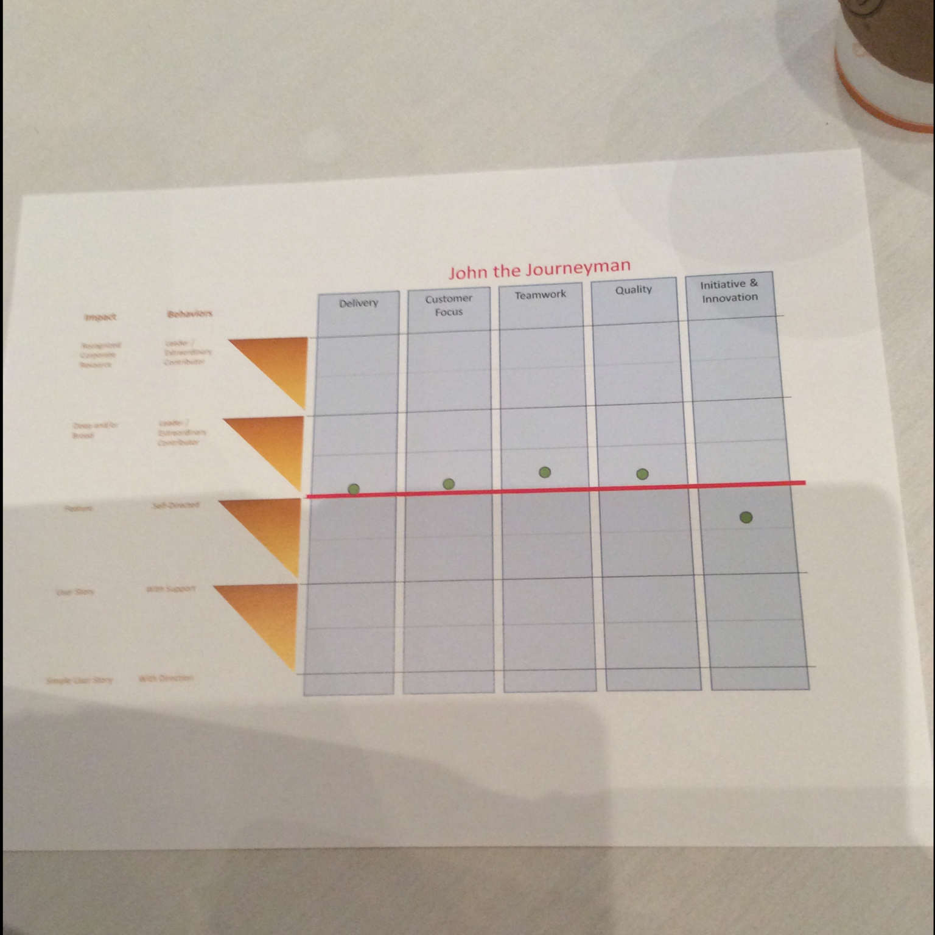
Red line is expectation line Senior guy is self directed
Managers found the visual format helpful
Coach behaviors But want impact One expected to drive the other but may not
Use strength to help the weakness
Managers view:
- How do managers like it - 100% really liked it
- Meaningful career development - 85%
- Improved perception of performance review - 92%
Employees view:
- 73% liked core responsibilities vs SMART objectives
- 57% think helped on career development
- 68% “my manager helped me what needed to get to next level”
Challenges when integrating with HR system
- HR ratings are about performance over career growth
- Coarse grade vs linear scale
- Possibility of redundant paperwork as this was rolled out
- Possibility of title inconsistency in the company (new vs old)

